**SULEYMAN DEMIREL UNIVERSITY**

**ENGINEERING FACULTY**

**CSS 324 – Introduction to Machine Learning**

**Project documentation**

**Made by: Askarova Aisha**

**Temirbekova Dilnaz**

**Gylymmedden Yerkebulan**

**Kaskelen, 2020**

**Structure:**

* Abstract
* Introduction
* Aim and objectives of research
* Background Review
* Methods and Materials
* Data and Results
* Discussion
* Conclusion

References

* **Abstract**

Machine learning (ML) provides methods, techniques, and tools that can help solve diagnostic and prognostic problems in various fields of medicine. ML is used to analyze clinical parameters and their combinations for prognosis, such as disease progression, for maintenance therapy of treatment, and for general patient management. In our time, computer systems have already begun to be introduced into the healthcare environment, which makes it possible to facilitate and improve the efficiency of medical professionals and ultimately, improve the efficiency and quality of medical care. Below we want to tell you what are the main applications of ml we used in our application and show how they can be useful for medical care. We wanted to combine all the useful functions that can help people in the field of medicine. Application will help you determine the authenticity of medicines and with the help of recommendation systems and algorithms (KNN) to help in the selection of medicines. The application will be available on two platforms iOS as well as for android as it was implemented through the Flutter framework in Android Studio. Also used jupyter notebook, numpy, pandas, matplotlib, scipy and scikit-learn for data prepositions.

* **Introduction**

The smartphone in the 21st century is an integral part of many people's lives. Globally, there are about 2.6 billion smartphone subscriptions, and by 2020, this number is projected to reach 6.1 billion [1]. Smartphones with multimedia capabilities open new possibilities for app development and service delivery . Recently, smartphones have started to be used for medical purposes to measure numerous vital parameters such as heart rate (HR) and body temperature. This enables the use of a smartphone as a wireless HR monitor .At the moment, a huge part of society simply cannot imagine their life without this device. With the development of technology, smartphones can now become excellent assistants in the field of medicine.

SMM (Support Medical Machine) is a mobile app for home pharmacy inventory with an intelligent reminder system. It will help you create reminders for taking medications in a matter of minutes, as well as help with the calculation of originality of the drugs, thanks to the KNN algorithm , it will help with the choice of medicines, based on your individual characteristics. Travel will become easier when you have a global pharmacy locator in your pocket. You can also swipe your finger across the camera lens, activate scanning from the app, and after a few seconds, your heart rate will be detected and displayed.

**Aim and objectives of research:**

Aim

According to statistics and official data, in Kazakhstan, the share of counterfeit medicines accounts for more than 1%, in reality, this figure is certainly higher. Falsification has several types, as you can see, fakes can be both a good copy , as well as cause irreparable harm to health.

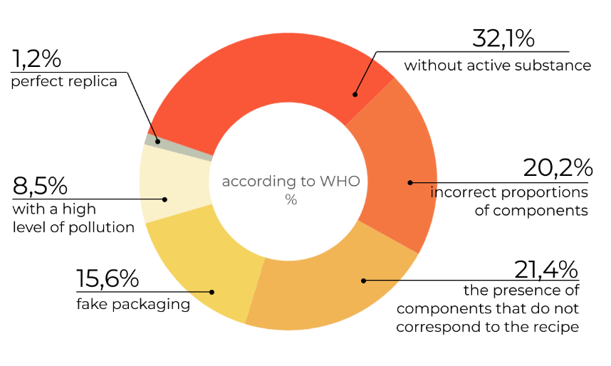

(Types of counterfeit medicines)

According to WHO statistics, the world's drug-related deaths are ranked fifth. The reason for this is poor-quality medicines.

To solve this problem, we decided to use the official database of the ministry of medicine of the republic of Kazakhstan for checking originality and construct right recommendations system for drugs. Make heart rate measurements available to all smartphone owners.

Objectives:

Collect data of drugs with official registration code

Collect data for recommendation system

Collect photos of drugs for text recognition

Use an algorithm to calculate the recommendations

Develop a flutter app

Link Flutter to python and parse data from python to Flutter

Make a text recognition system

Make heart rate system.

* **Background/literature review**

The pandemic has changed people's lives. We have started to pay more attention to our health and quality of life. During the pandemic, we came across substandard and fake medicines. thanks to machine learning and our program, people can check medicines for authenticity and have a medical assistant at hand who can recommend the right similar medicines thanks to the ML algorithms, recognize fake drugs and measure heart rate. The number of poisonings from low-quality medicines will decrease.

* **Methods and Materials**

Main part: Flutter, Python, Jupiter Notebook,Dart SDK

The design was developed using Figma, Photoshop and in XML. The project contains 1 main windows with 3 Containers, window foe reminder system:

1. Authorization menu

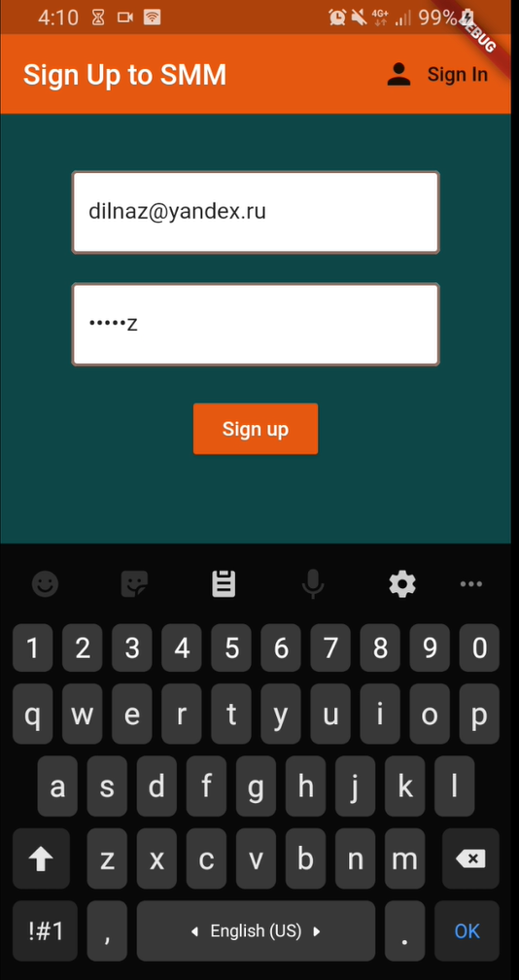Email and password are used for authorization

1. Main window

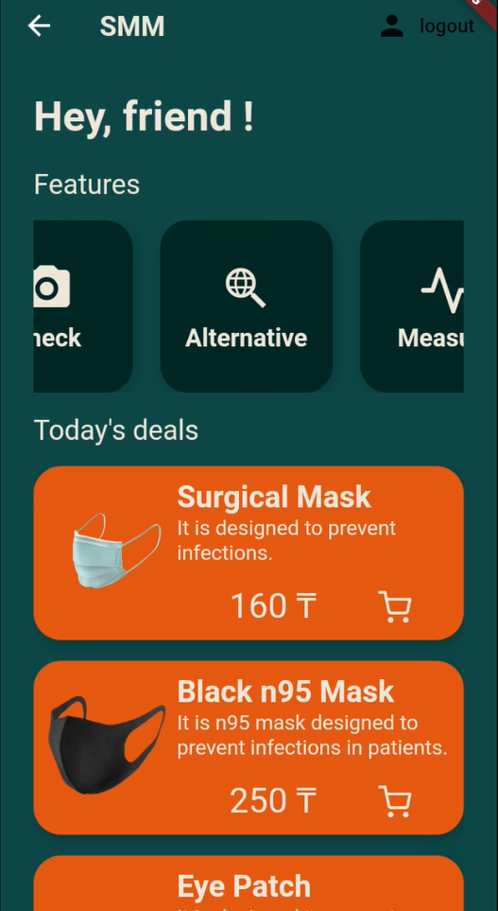Main window - a welcome window with 3 categories, shop list that leads to the second one with a menu for reminder system .

* 1. *Category “Check”*- Opens the photo gallery, select a photo, the program performs text recognition on the image, finds the registration code and checks it for its presence in the database.
  2. *Category “Alternative”*-Enter the name of the drug, the program uses a recommendation system and displays the names of similar drugs that are similar in composition from the database.
  3. *Category “Measurment”*-The app measures heart rate and displays it in a chart using onlyер the phone’s camera and flash.

requirements from the database.

1. Reminder window

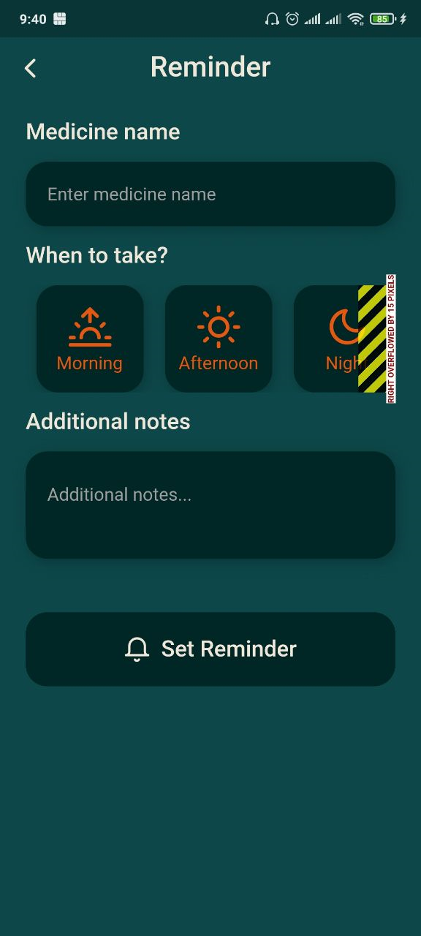Reminder windows help create reminders for taking medications in a matter of minutes

IDE: Android Studio, Jupiter Notebook, Pycharm, VC Code

Additional Tools: Excel, Google ML-Kit library, Flusk, Python

**Data and Results**

Collecting the data:

Data for text recognition and authentication:

To prepare data and implement algorithms, we used Jupiter notebook with the pandas library,sklearn, etc. All data is in csv format. The data for authentication by text recognition was taken from the state open data portal egov (https://data.egov.kz/datasets/view?index=gosudarstvenniy_reestr_lekarst)

Data attributes:

name (text): name of the drugs

countryry(text): country of manufacture

regidru(text): registration number

recipru(categorical): recipe

id(numerical):id number

data(date): expiration date

atcclassificationru(text): classification of ATС

producerru(text): manufacturer

classificationru(text): the classification of drugs/medical devices

drugsformru(text): dosage form

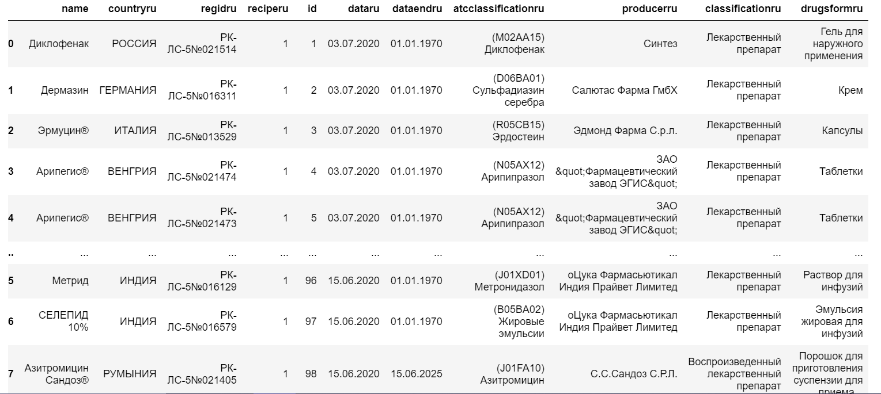

Data for recommendation system:

Data for recommendation is from <https://archive.ics.uci.edu/ml/datasets/Drug+Review+Dataset+%28Drugs.com%29>

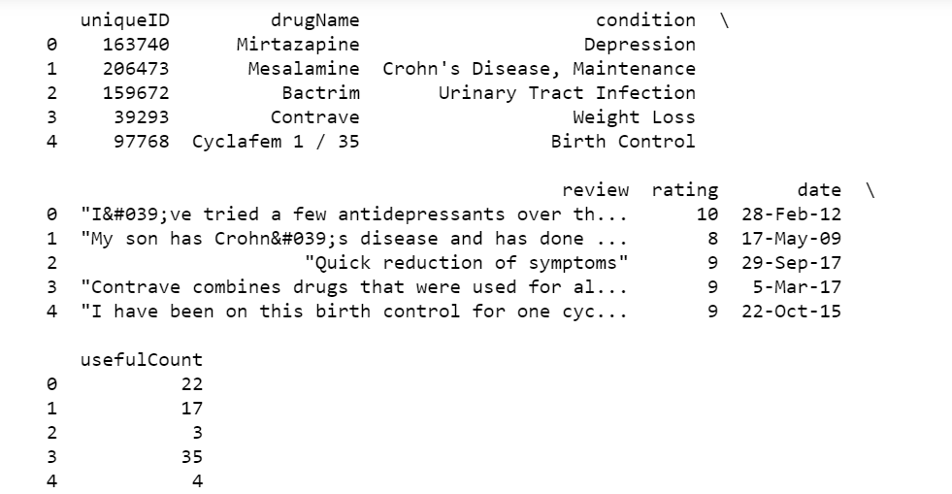

The dataset provides patient reviews on specific drugs along with related conditions and a 10 star patient rating reflecting overall patient satisfaction. The data was obtained by crawling online pharmaceutical review sites.

Data Information:

1. drugName (categorical): name of drug

2. condition (categorical): name of condition

3. review (text): patient review

4. rating (numerical): 10 star patient rating

5. date (date): date of review entry

6. usefulCount (numerical): number of users who found review useful

Recommendation system:

For the recommendation system, the KNN algorithm is used. The main parameters are DrugName(the name of the drug) ,condition ( purpose of the drug), usefulcount (number of times when the drug helped).

The algorithm searches for the nearest neighbors by these parameters and outputs the 5 closest ones. Possible drug alternatives are displayed.

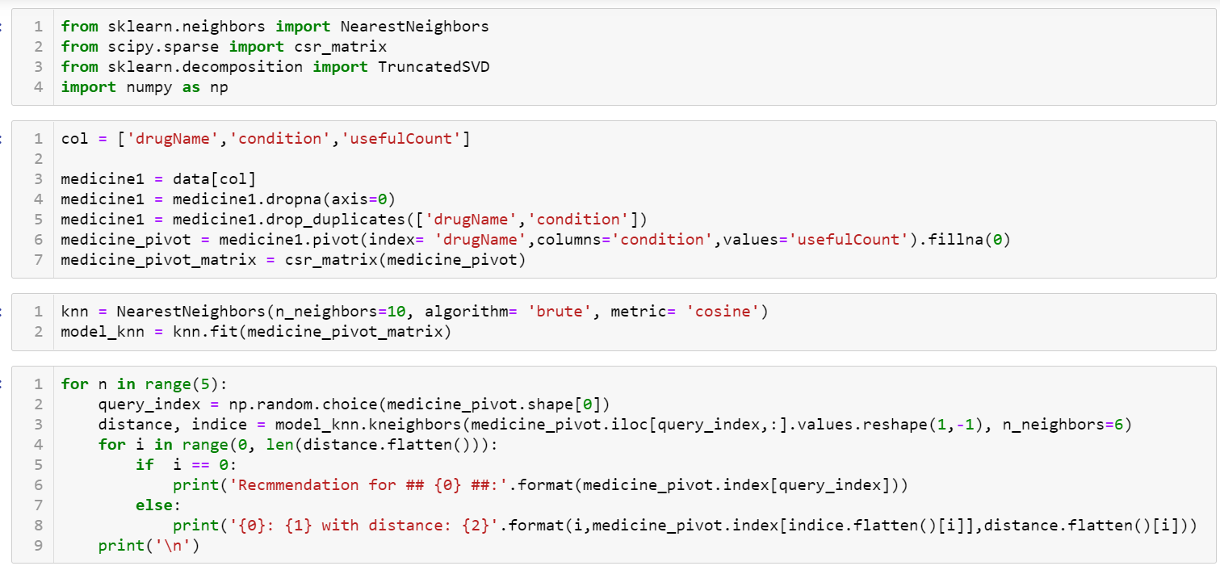

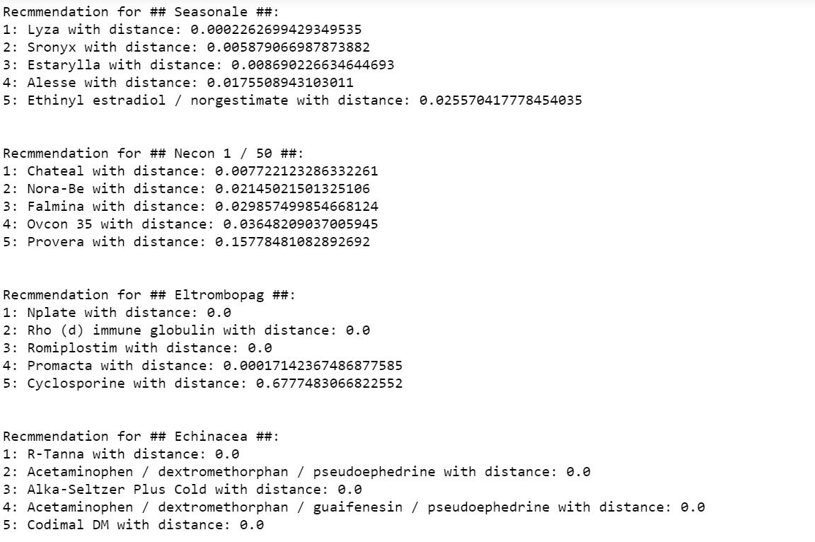

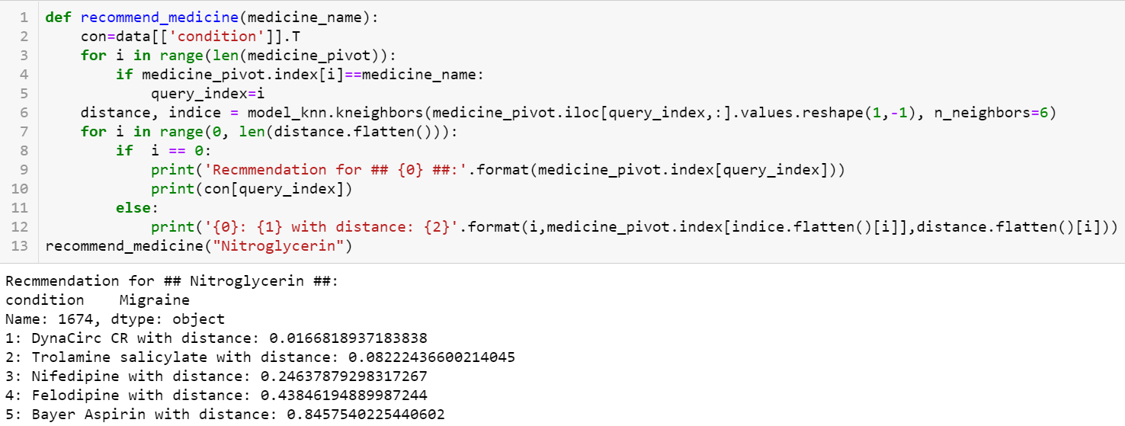

The ready-made recommendations that our code brought out were placed in a separate file. From the local host the request with the name of the drug is accepted, then we search for it in the file and output recommendations, if any flutter sends a request to the local host with the name of the medicine that the user entered and accepts recommendation data from the local host and displays it on the screen.

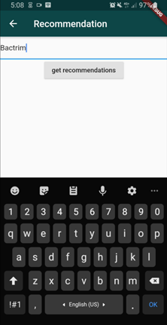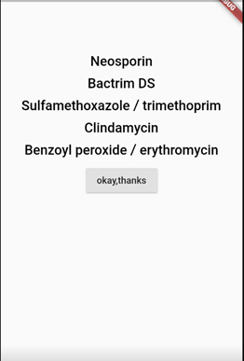

Text recognition:

To check the medicine for authenticity, we click on the “Check” button, which opens our gallery to select an existing photo. After selecting the desired photo, the program recognizes the text on the photo and finds the registration code, checks through our database of medicines and if it is in our database, then the medicine is original.

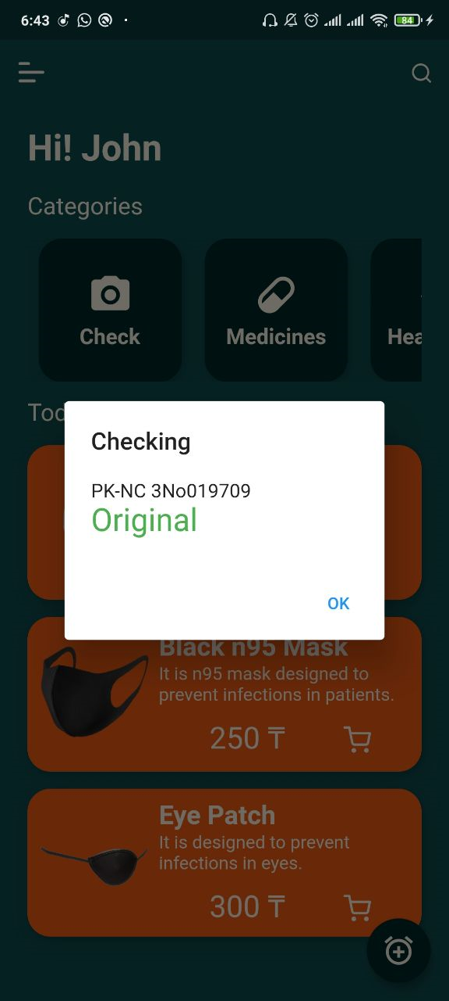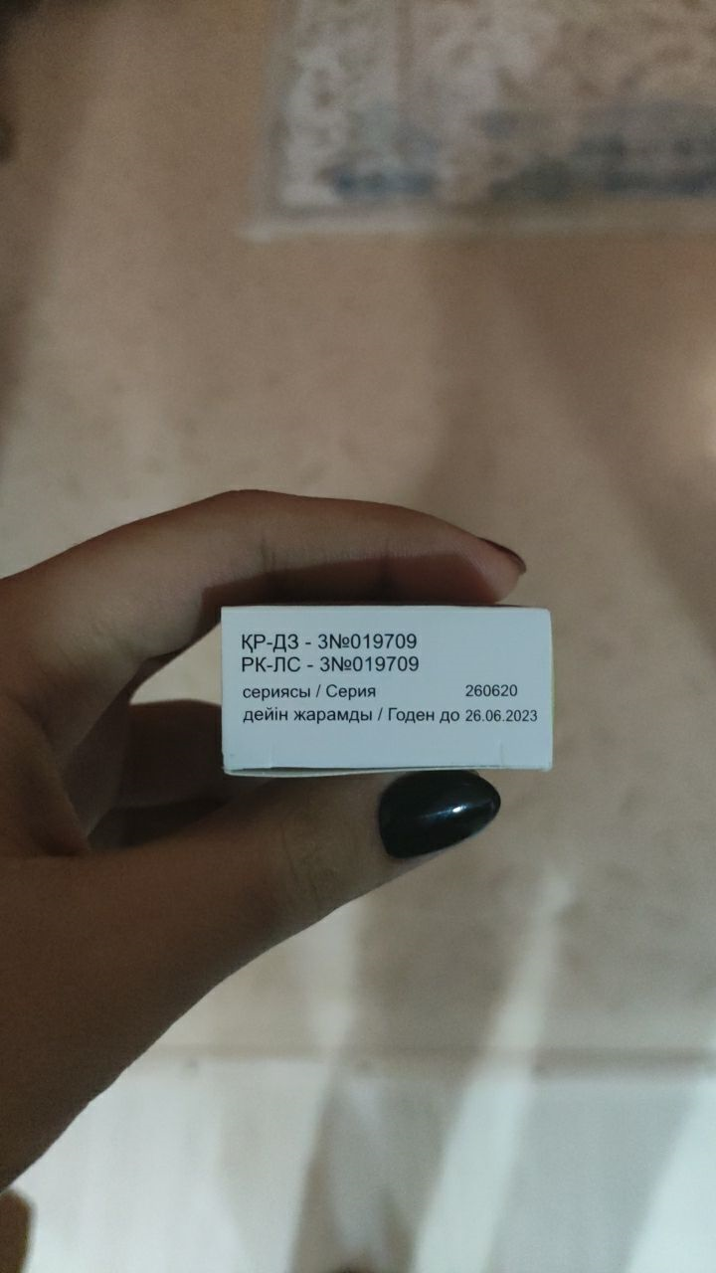

Registration codes are written in two languages, but we chose to search for the one that is in Russian because the Cyrillic alphabet is better recognized than the Kazakh alphabet.

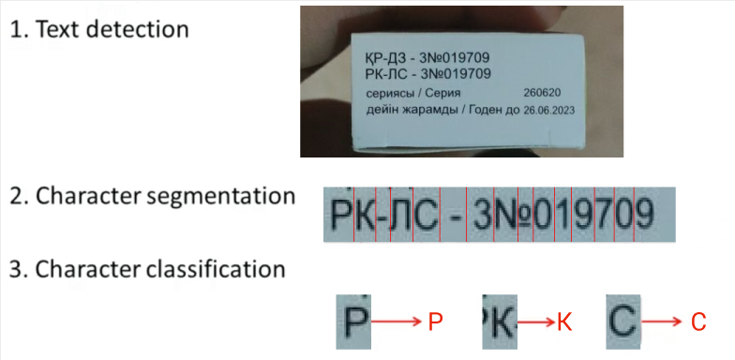

Accuracy of the recognized text depends on lots of factors including the quality of the photo, the angle of the text (such as less than 45 degrees of rotation deviated from the horizontal), lighting contrast and the resolution of your photo. For most cases, the recognition accuracy is quite good and acceptable though.

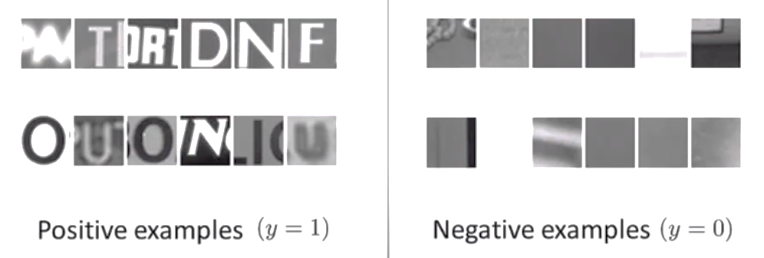

Positive examples (y = 1), patches with text

Negative examples (y = 0), patches without text

For implementation, we used the simple OCR plugin by Google's ML-Kit library

Heart rate system:

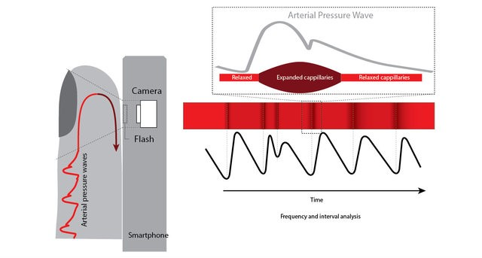Shining a light into a blood irrigated tissue, we can measure the variability of reflected light and extract the variation of blood flow. As we all know, the blood flow is dependent on the heart rate, so we can calculate the heart rate using the blood flow variation.

(Vandenberk, et. al. (2017). Clinical Validation of Heart Rate Apps: Mixed-Methods Evaluation Study. JMIR Mhealth Uhealth. 5. e129. 10.2196/mhealth.7254.)

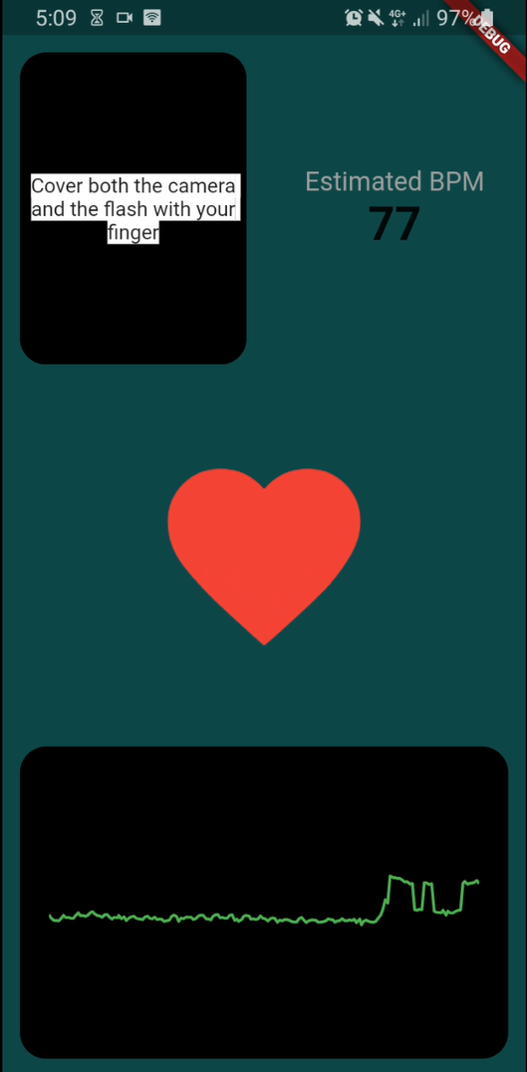So, in application you need shine the camera’s flash and the app measure the intensity reflected using the phone’s camera. More specifically, the app will measure the average value of all the pixel’s intensity of the camera image. Then, if we cover the camera and flash with our finger, the intensity measured will vary with the blood flow.

**Discussion**

Our tool will be very useful for users, data may not be completely accurate and for a complete analysis and diagnosis, we still recommend contacting a doctor. To take a drug from the recommendation system, it is better to consult a doctor in cases of personal intolerance, etc.

**Conclusion:**

In conclusion, we analyzed the situation with the sale of counterfeit medicines in Kazakhstan and found an increase in the sale and production of illegal medicines during the global pandemic. to solve this problem, thanks to machine learning algorithms, we made an application that will help in the selection of drugs and authenticity verification for the implementation of this idea, we used flutter, thereby increasing our target audience of consumers, since the application is available for both iOS and android users. In the 21st century, mobile devices have long been an integral and irreplaceable gadget of every person. but now with the SMM(Support Medical Machine) app, any mobile device will become your personal medical assistant. With the help of the KNN recommendation system algorithm and ML Kit libraries, the program provides a selection of medicines according to individual requests for each user, as well as using the text recognition technique, we check medicines by the registration code of the database provided in the official state portal egov. thus, we will reduce the risks of poisoning and mortality from low-quality medicines.

**References:**

1. Duda R, Hart P, Stork D: Pattern Classification. 2nd edition. New York, NY: John Wiley & Sons, Inc.; 2001.
2. Breiman L, Friedman J, Olshen R, Stone C: Classification and Regression Trees. Boca Raton, FL: CRC Press; 1984.
3. Tadeusiewicz R, Ogiela MR: Automatic understanding of medical images new achievements in syntactic analysis of selected medical images. Biocybern Biomed Eng 2002, 22(4):17–29.
4. Mitchel T: Machine Learning. New York NY: McGraw Hill; 1997.
5. Application Example Photo OCR, Lecture 18.2 Andrew Ng. Сoursera;2019.